
The Weekly Bulletin of the Rotary Club of Kathmandu Mid-Town - Volume No. 17/04 for # 797 August 10, 2005
Editor: CSD Rtn. Walter Diller Layout: Rtn. Navyo Eller Web: www.rotarymidtown.org.np BC-email: diller@htp.com.np
THE BREAKFAST CHATTER

MIDTOWNERS SUNSHINE OF THE WEEK ► AUGUST, 12-19, 2005
SUNSHINE ANNOUNCEMENT FOR THE WEEK OF 05 August, 2005:
this time we had three birthdays and a sunshine collection of NPR 1500. Not bad.
► No sunshine announcement this week

SPEAKER OF THE WEEK ► BIBHUTI MAN SHRESTHA – RC Kathmandu West.
THEME | DISATSTER MANAGEMENT
Nepal’s quake prone land which is little protected against disasters.
A presentation of a concept to minimize the negative results of an earthquake.

UPCOMING SPEAKERS ► PREVIEW
DATE | SPEAKER | THEME
19 AUG | Dr Hedamba Rajbandari  Chairman ND group and former secretary of Agriculture | Agro processing, a winners game?
26. AUG | Dr. Maksha Ram Maharjan, Project coordinator Care Nepal | Peace Building and Good  Governance through Community Forestry
02nd SEP | Shrestha, Ashish PPP model & advocacy | how can public and private sectors work reasonably together
09th SEP | Mr Shinji Joshiura , resident representative JICA | Activities of Japan International Cooperation AGENCY in Nepal

THE LAST SPEAKER OF MEETIMG # 794 ► OUR PP GOPALJEE
It wasn’t so much a speech but a film (power point presentation of course, but looking like a film). A bit shaky film but a presentation which let the Nepali heart become beating proudly as the event concerned the support of Rotaracts climbing the Mount Everest in a new way.

A way where an exhausted man meets up in the sky a charming lady which fascinates him so much that he says yeas to be with their whole life.

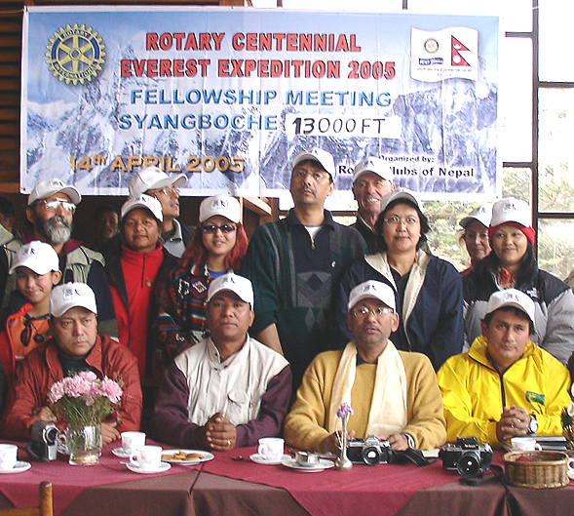
Three members of the Rotaract Club of New Road City, Nepal, told the audience of their ascent to Mount Everest earlier this year. Moni Mulepati Sherpa, Prem Dorjee Sherpa, and Kami Sherpa brought the flag they hoisted atop the world's highest peak and presented it to RI President Glenn Estess Sr., who waved the flag to the roaring cheers of the audience
Quite impressive how Gopalji helped to manage to get Nepal to the positive attention of many thousand Rotarians.

Another good news was that this time around 150 Nepalis visited the centennial convention

THE MIDTOWN CLUB ► NEWS
This time a sad news.

Rtn. Peter went back to US withour celebrating his good bye even. We definitely will miss him and his valuable contributions.

This Sunday change of venue and time. It will be in Grand Hotel Sunday morning at 8am. It’s the first joint meeting of this Rotary year. It will be on disaster management, make it a success.

Roop as usual is also a supporter of the clubs members mentality. “If you are a real Rotarian than 7.30 am isn’t an impossible time to come and participate at the club meetings.” Right he is.

You want to celebrate?

Rotary club of Bagmati in association with Namuna Fashion Institute is organizing a JOURNEY OF FASHION which should be regarding the experience of Namuna Fashion institute attractive. In addition a cocktail dinner will follow. But more to it. The proceeds are supposed to aid Breast Cancer Support program of Nepal Cancer Relief Society. It will take place on Sunday 14th August 2005 at Hotel Soaltee Crown Plaza.
The total contribution for this program including cocktail dinner is NPR 1299/- . Have a nice time.

For your information

Kathmandu Midtown has always been a forerunner for polio eradication in this country. Therefore the following might be interesting. In letters to influential colleagues, United States Senator Elizabeth Dole is urging support for budgetary requests totaling $138.4 million in continued government funding for polio eradication activities during the 2006 fiscal year.

RI District 3290 cordially invites all Rotarians

Seminar on Rotary Foundation on Aug 10, 2005 hosted by Rotary Club of Mt. Everest, and

Seminar on Membership Development on Aug 11, 2005 hosted by Rotary Club of Patan

Regional Rotary International Membership Coordinator PDG Rtn Rupak Jain,
Rotary International Zonal Public Image Coordinator, DG Swapan Mukherjee, PDG Sekhar Mehta, DGE Debashish Mitra and DGN Anirudh Roy Chowdhury will be attending the Seminars.
Presence of All Presidents, Secretaries, Club Service Directors and Chairs, Membership Development Committees of the clubs is mandatory.

Programme:
Day 1: August 10, 2005 Wednesday, Time 5.30 PM, Venue Hotel Himalaya
Day 2: August 11, 2005 Thursday, Time 4.30 PM, Venue Hotel Himalaya
Registration for a) 1 day: NPR 450/person b) 2 days: NPR 750/ per person

Program will be followed by Dinner and Pay Cocktail

A WORD ON ROTARY ► GURJIT SINGH – JIM THOMPSON
Gurjit Singh, President, RC of Ludhiana North, Punjab, India

The 100-year anniversary will not come back in our lifetime, so this has been a unique opportunity. What I learned from this convention is that every Rotarian has love in their minds. Everybody was very helpful."

Keeping kids off the streets

A Q&A with Jim Thompson, founder/president of StreetKeepers and member of the Rotary Club of Guelph Trillium, Ontario, Canada

Rotary International: What is the StreetKeepers project?
Thompson: StreetKeepers is an organization of Canadian Rotarians from District 7080, who are working with children that have no parents and are living on the streets in India, Nepal, and other Southeast Asian countries. Our purpose is to find ways of taking as many children off the street as we can.
RI: What motivated you to start StreetKeepers?
Thompson: While in Kathmandu, I remember seeing a tarpaulin on the side of the road. I went over and lifted the corner of the it, and what I saw under there made my heart stop. There were three or four, maybe five little kids under the tarpaulin— about 7 to 9 years old — and they were all huddled together like a litter of puppies. And when I saw that, something just happened in my heart.
RI: How do you raise money for the project?
Thompson: We encourage Rotary clubs all over the world to contribute C$500 to our project each year. Our board gives feedback to participating clubs about every two months so that they can see what their Rotary dollars are doing. They can also meet the children they are helping.
RI: Do you work with local Rotarians to help these children?
Thompson: We work with local Rotary clubs in India and Nepal and with partners we know are very reliable and are skilled in working with street children. So we raise the funds, the local Rotary clubs mentor the children and oversee the projects, and local organizations with sound reputations, such as Good Shepherd Sisters in India, provide the day-to-day care.
RI: Has there been a lot of interest in your project at the convention?
Thompson: There has been tremendous interest, because it’s a project for kids that can literally save lives.

SEE YOU ALL COMING FRIDAY ► YOURS IN ROTARY - CSD RTN. WALTER DILLER
THE BREAKFAST CHATTER
The Weekly Bulletin of the Rotary Club of Kathmandu Mid-Town
Editor: CSD Rtn. Walter Diller Layout: Rtn. Navyo Eller
Web: www.rotarymidtown.org.np BC-email: diller@htp.com.np

